**Random Forest :**

**→ Forest indicates that this is some collection of trees.**

**→ In Random Forest we need labeled data. So, it is a part of supervised learning.**

**(1) Read the data :**

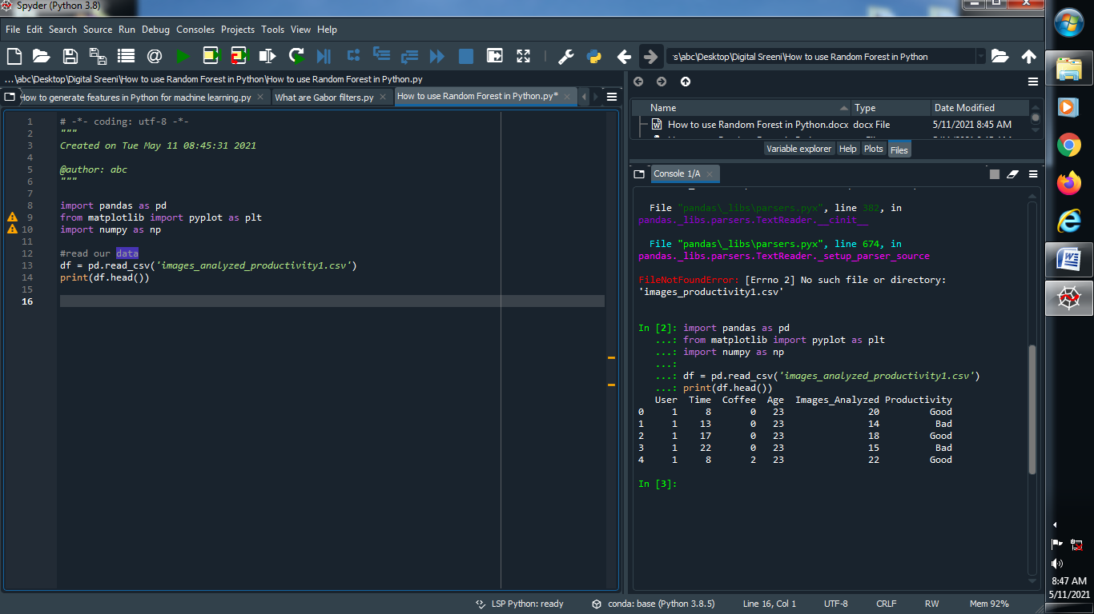

**Output :**



**(2) Let’s see how many values are good or bad :**

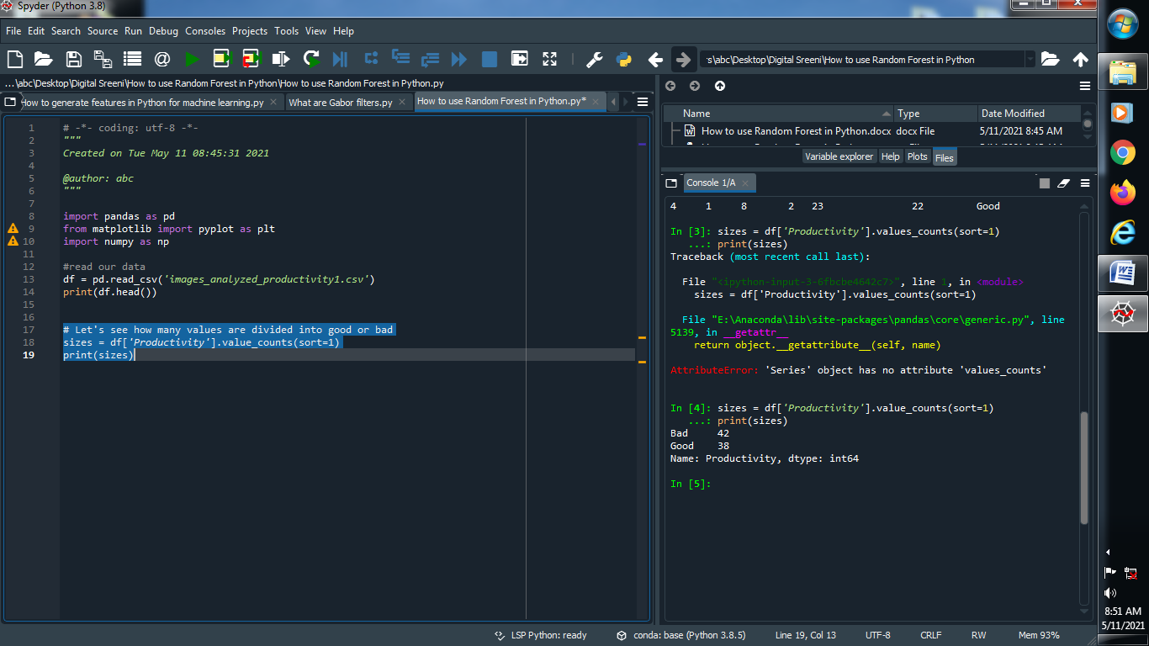

**Output :**



**(3) Drop independent variables :**

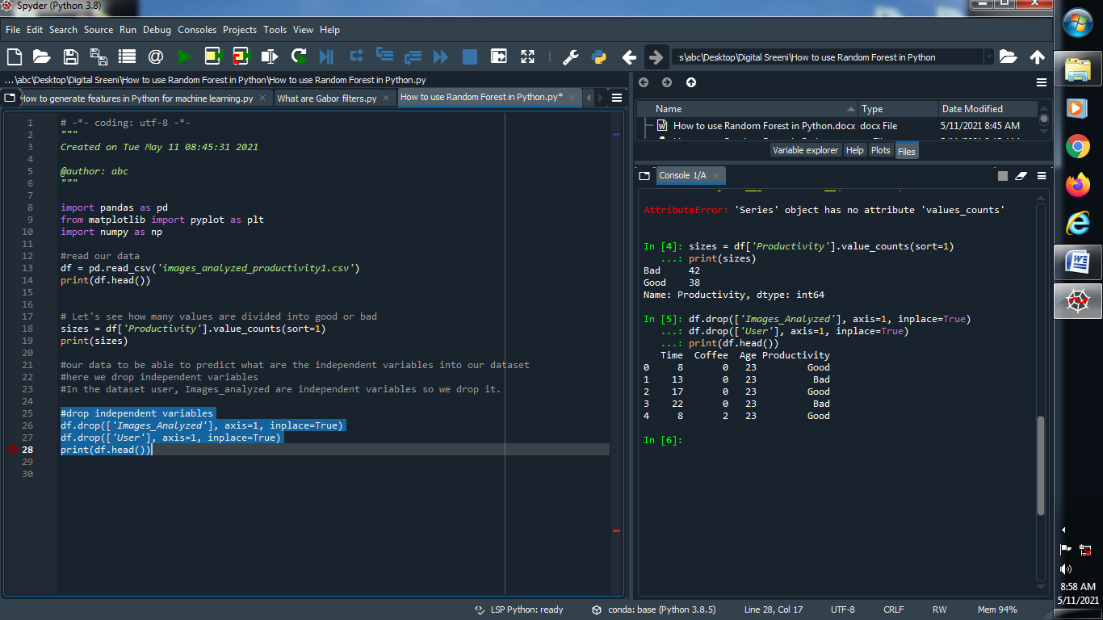

**Output :**



**(4) Handle missing values :**

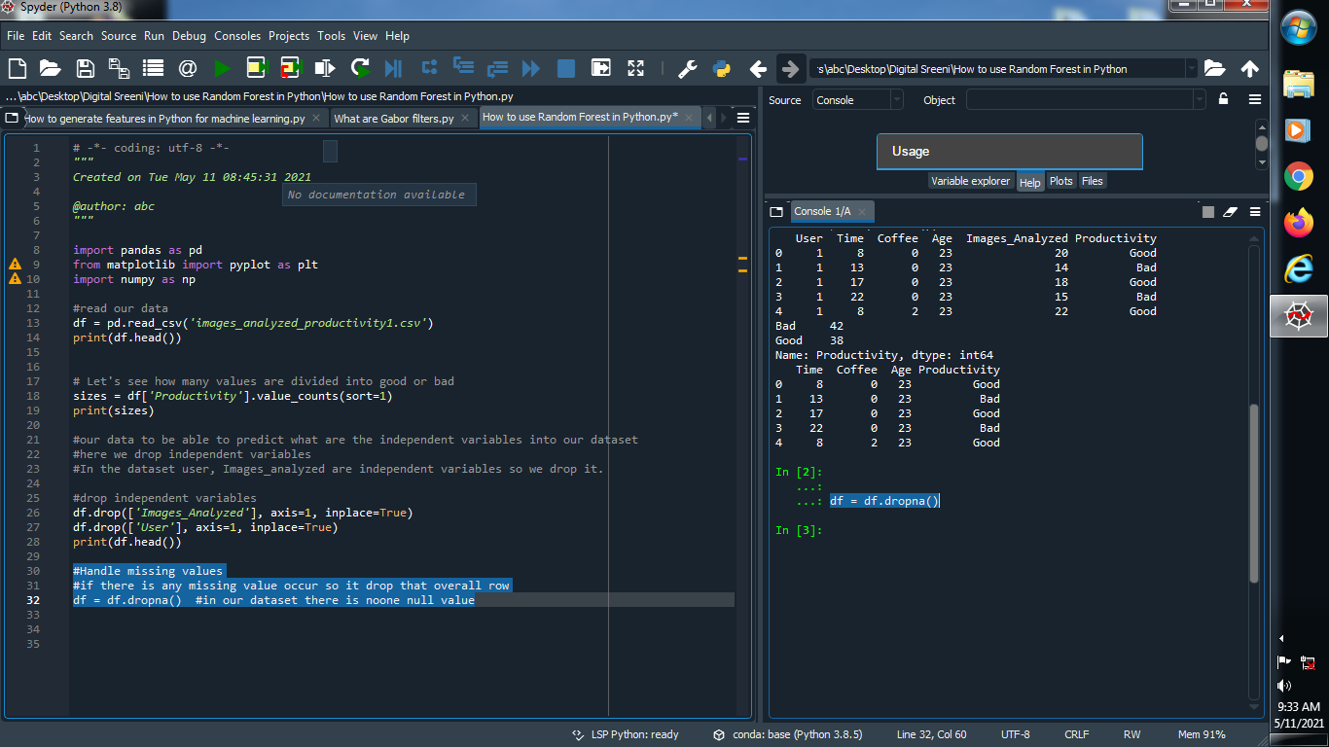

**Output :**



**(5) Convert Non-Numeric data into numeric data :**

**→ In our dataset there are two non numeric data good or bad convert it into 1 or 2 like numeric data**

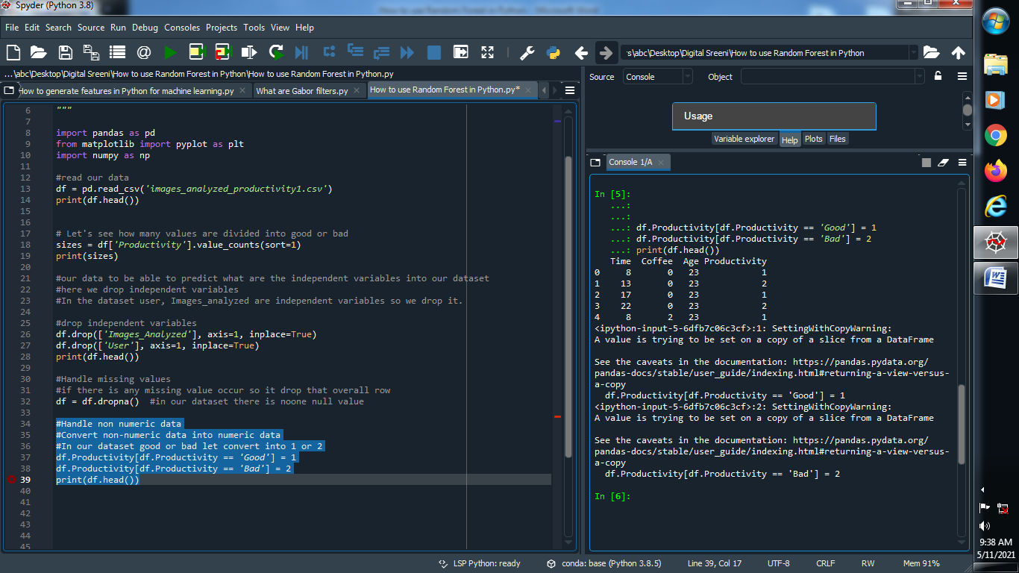

**Output :**



**(6) Define independent variable and convert that variable into integer :**

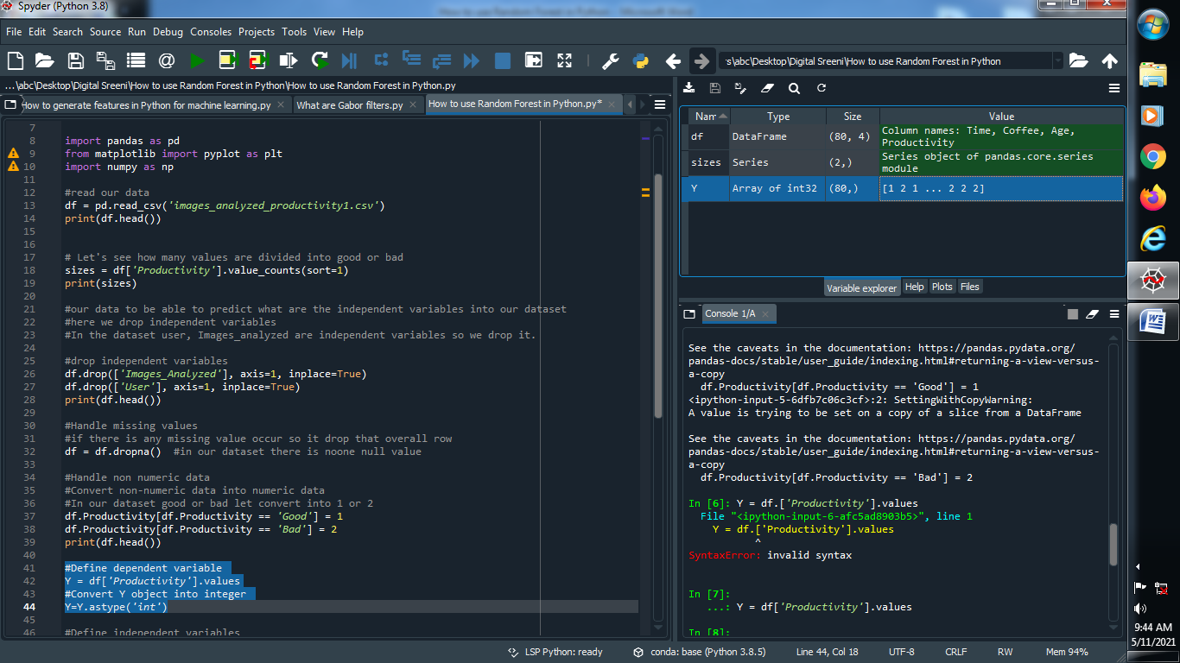

**Output :**



**(7) Define dependent variables :**

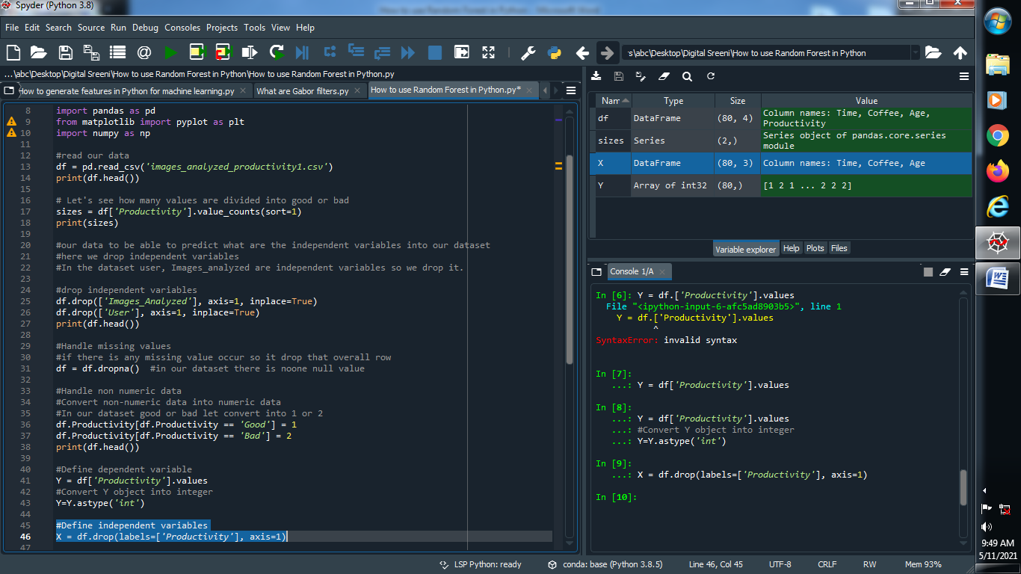

**Output :**



**(8) Split our data into training and testing purpose :**

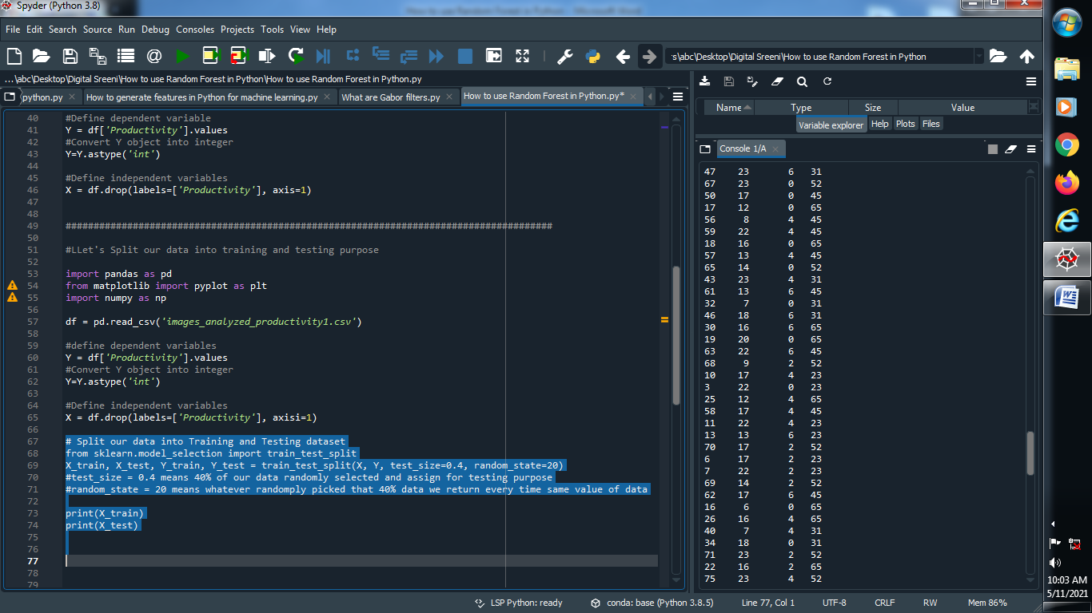

**Output :**

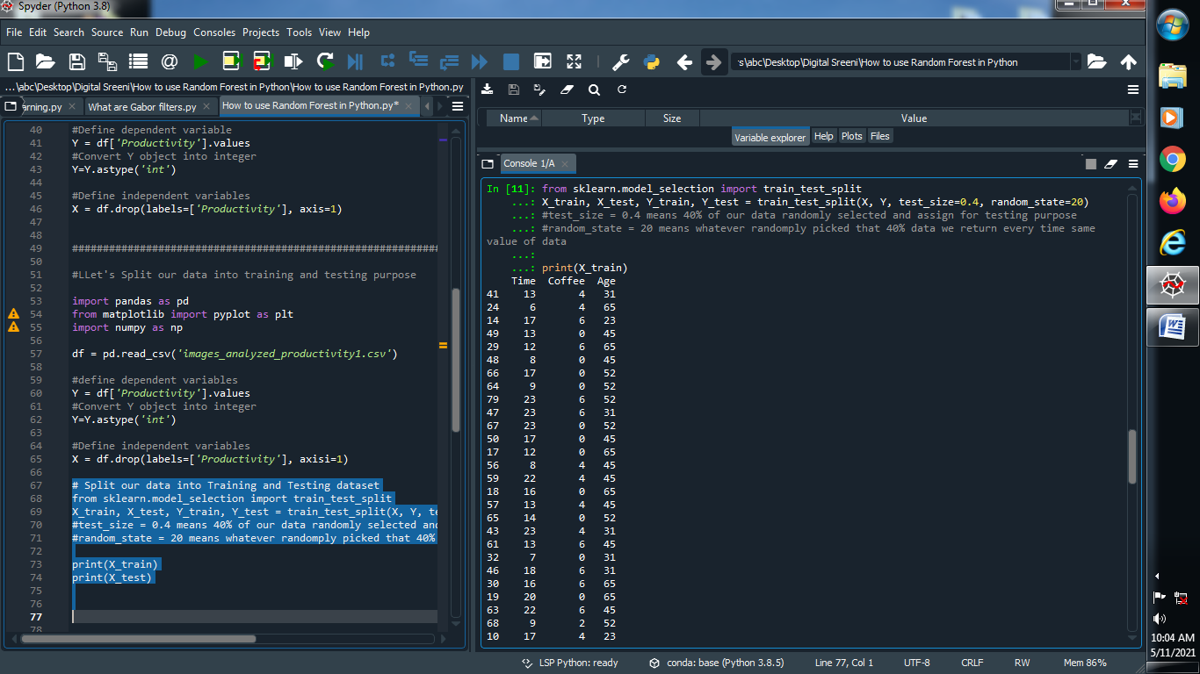

**(9) Apply Random forest :**

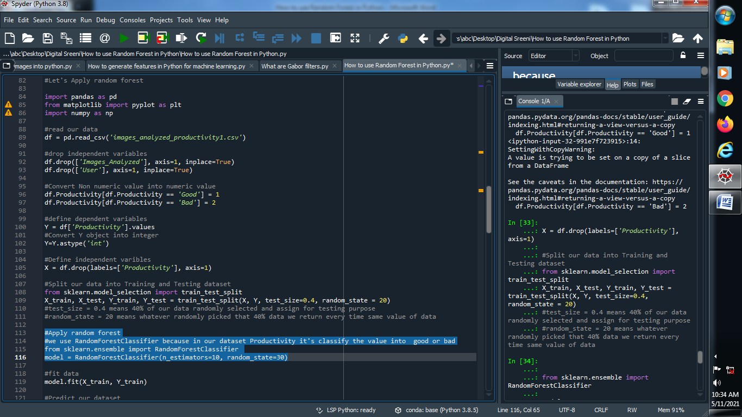

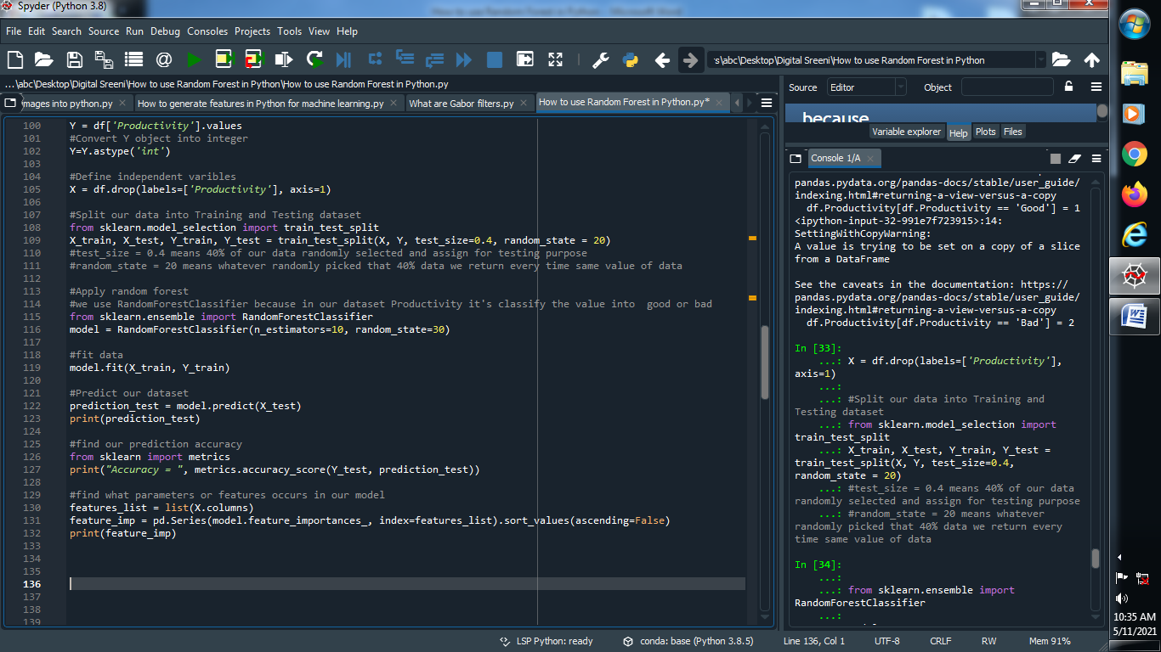

**Output :**

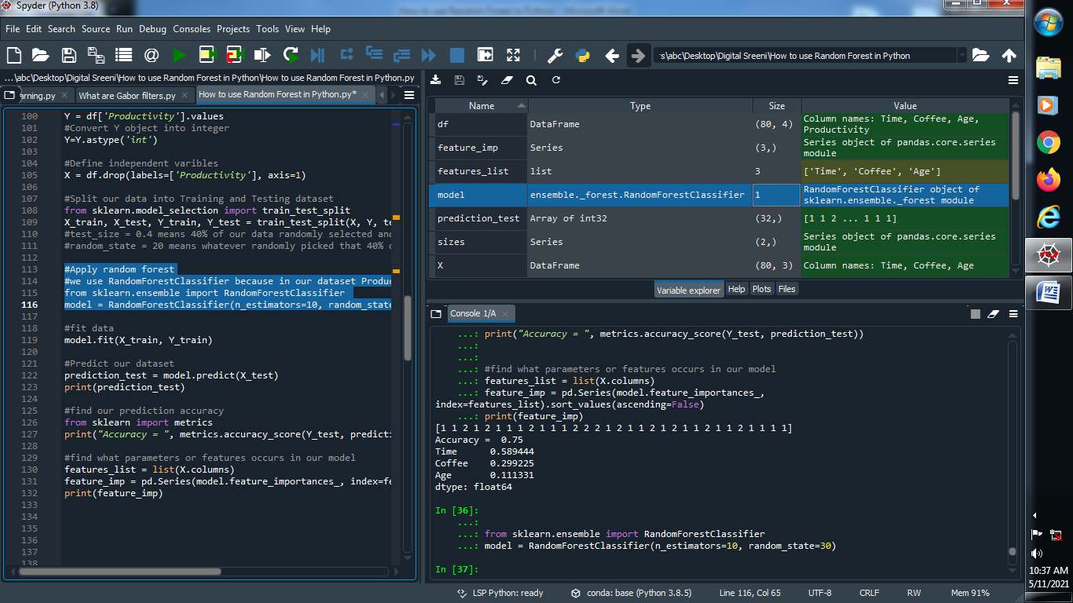

**(10) Fit our model :**

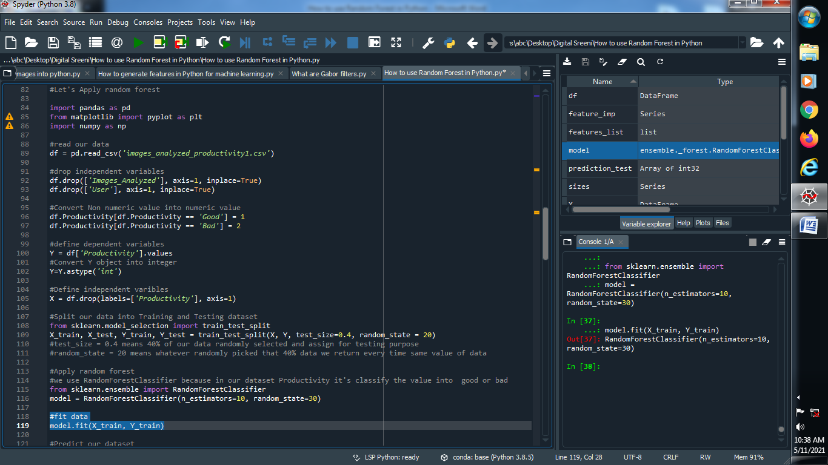

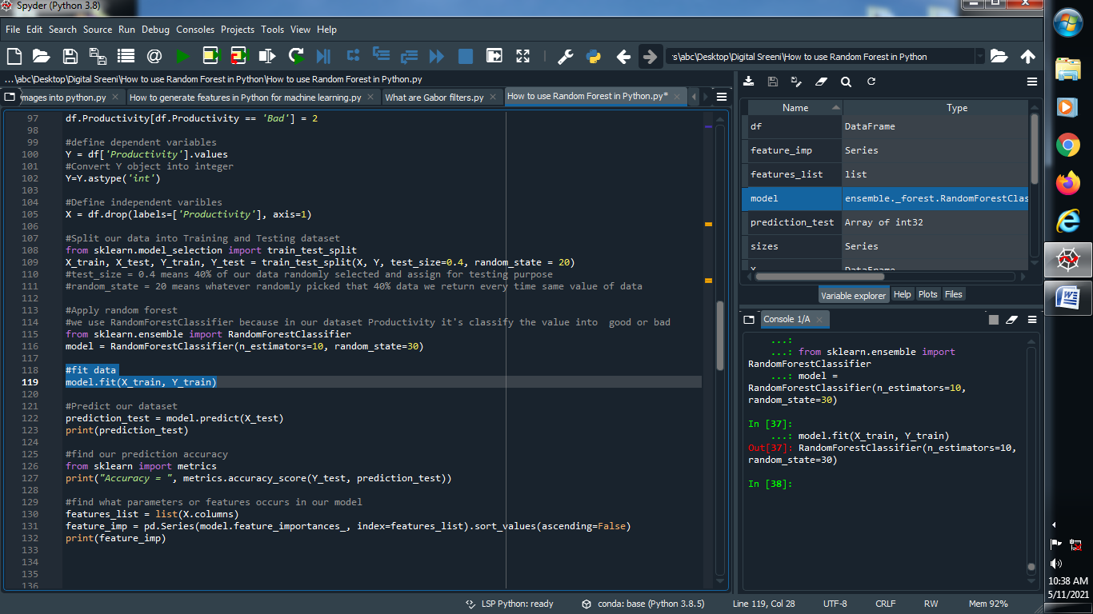

**Output :**



**(11) Predict our model :**

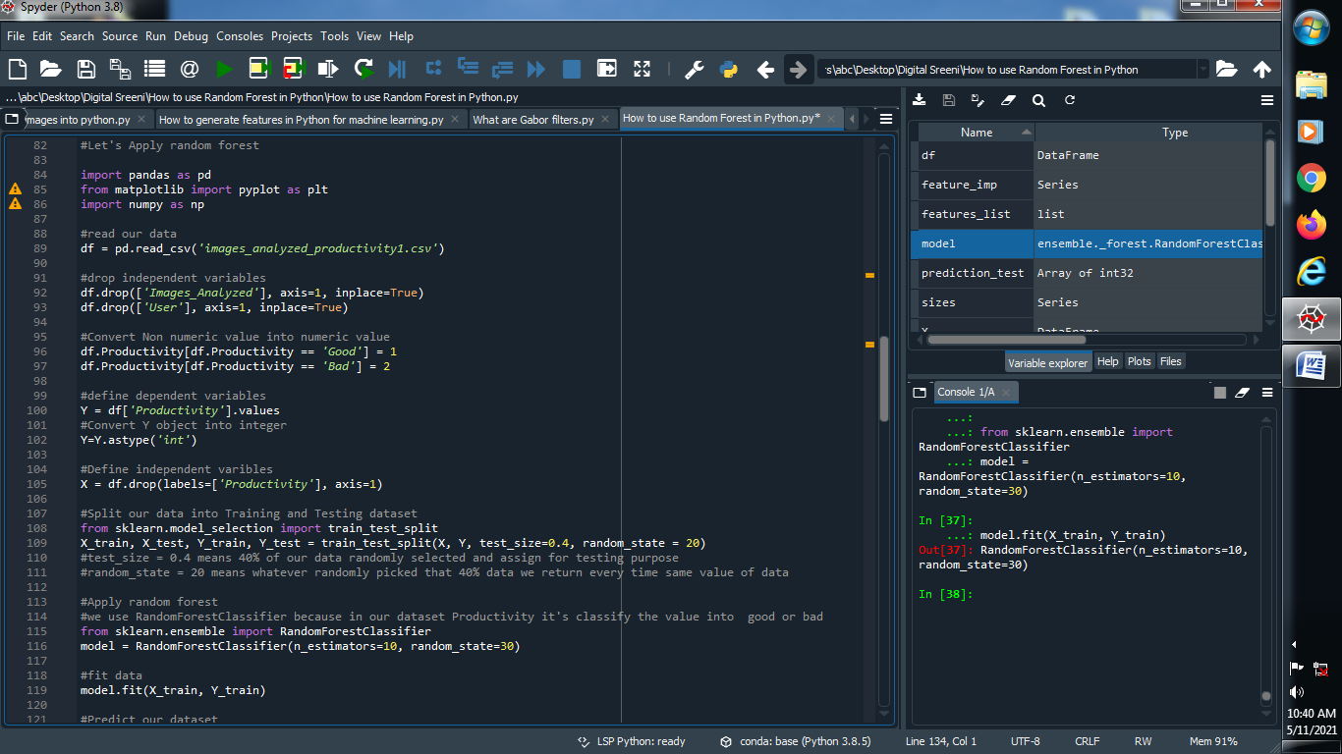

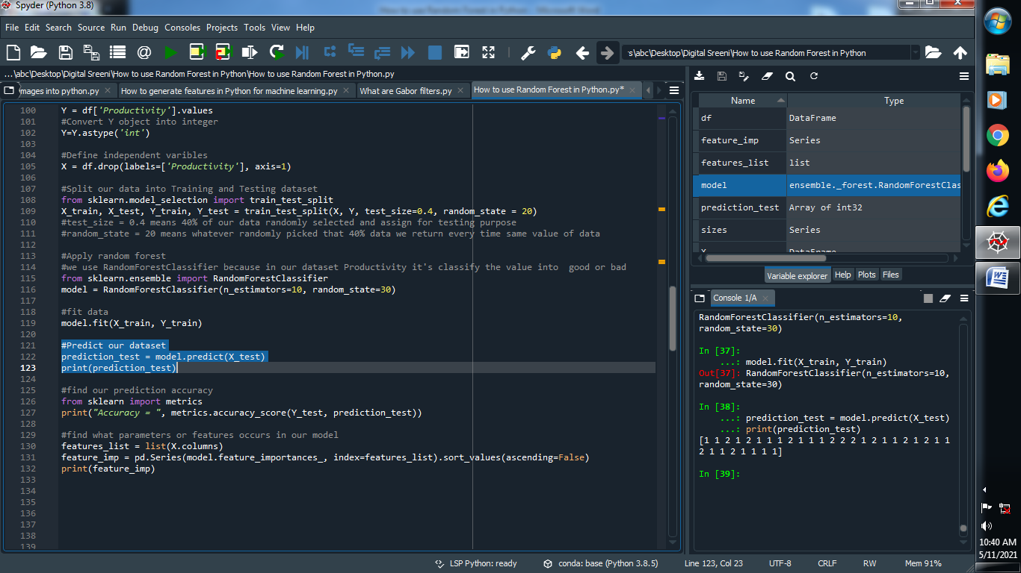

**Output :**

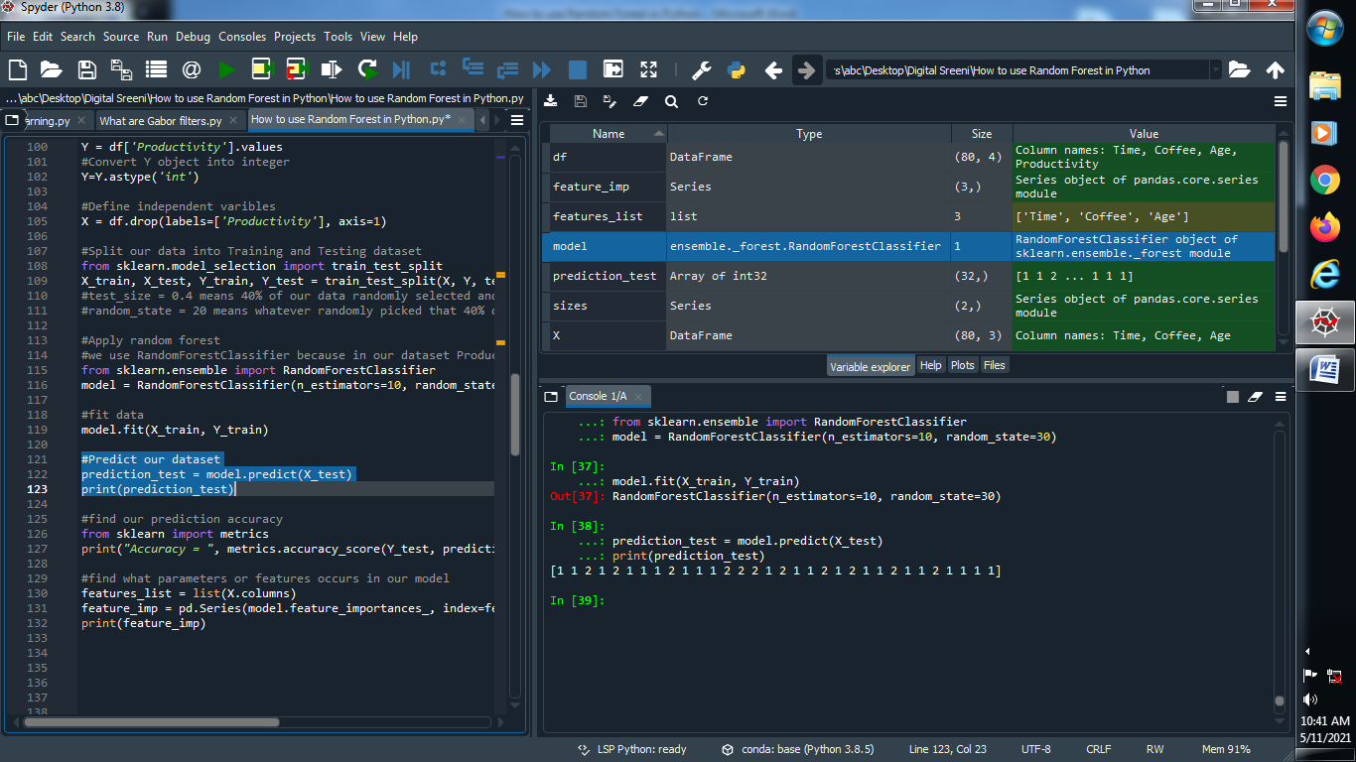

**(12) Find the accuracy of our prediction :**



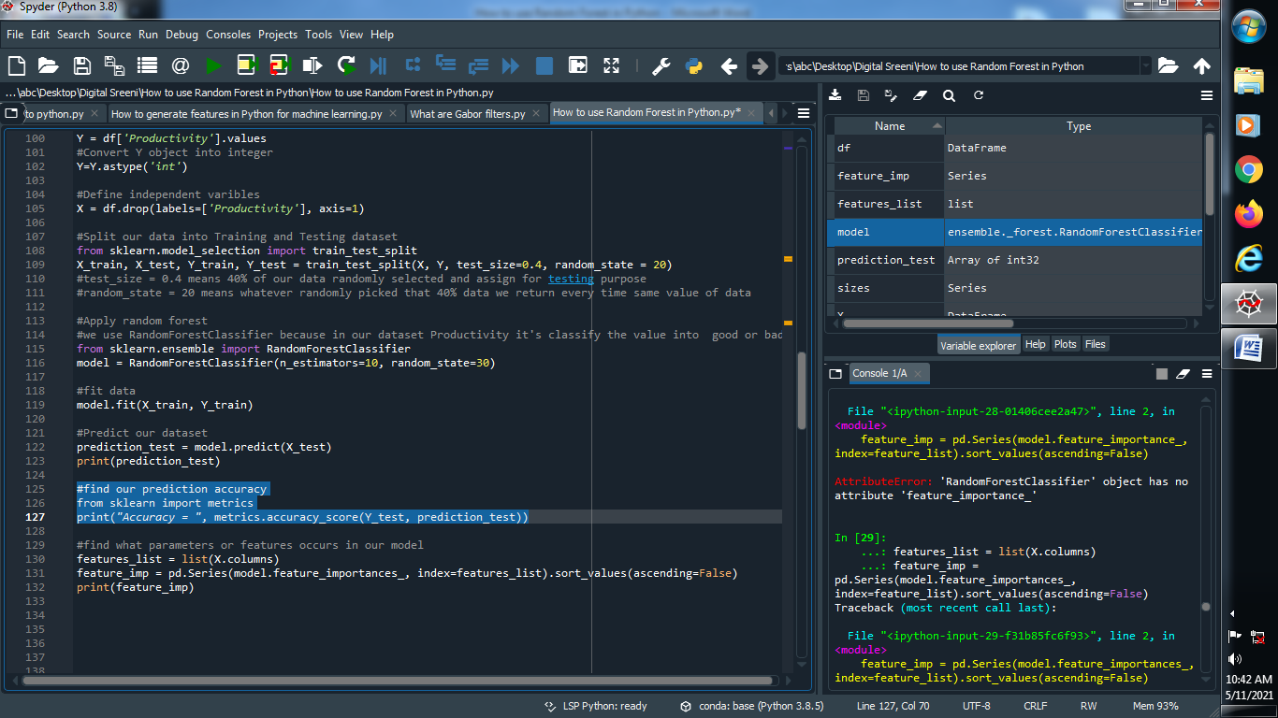

**Output :**

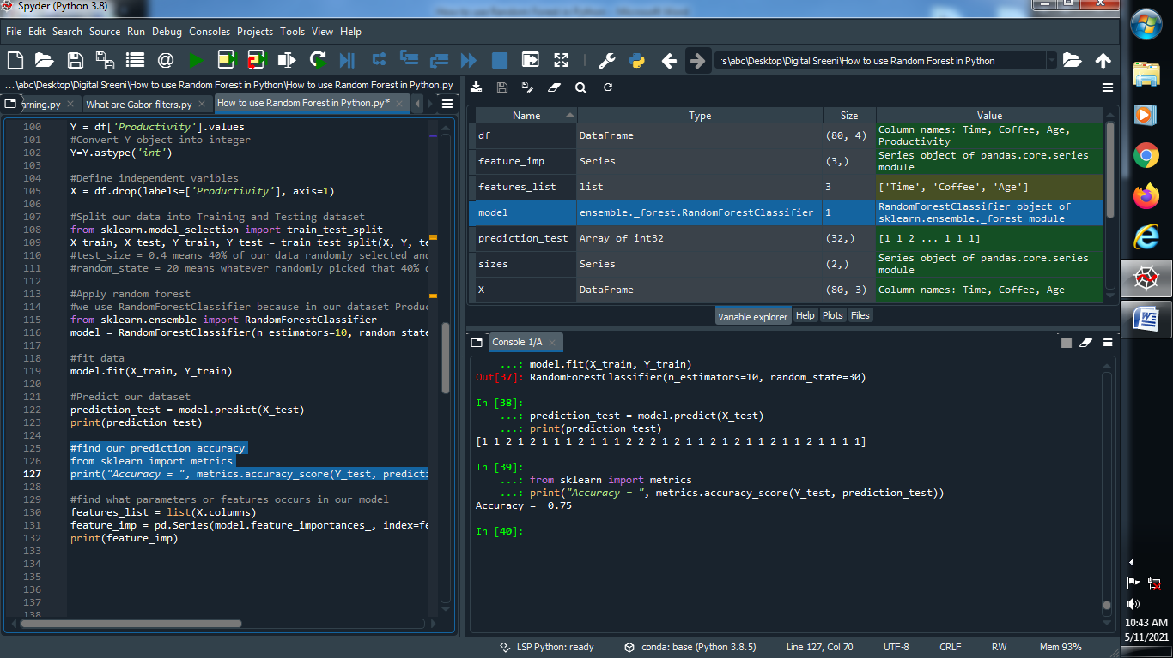

**(13) Find the features ratio in our prediction :**



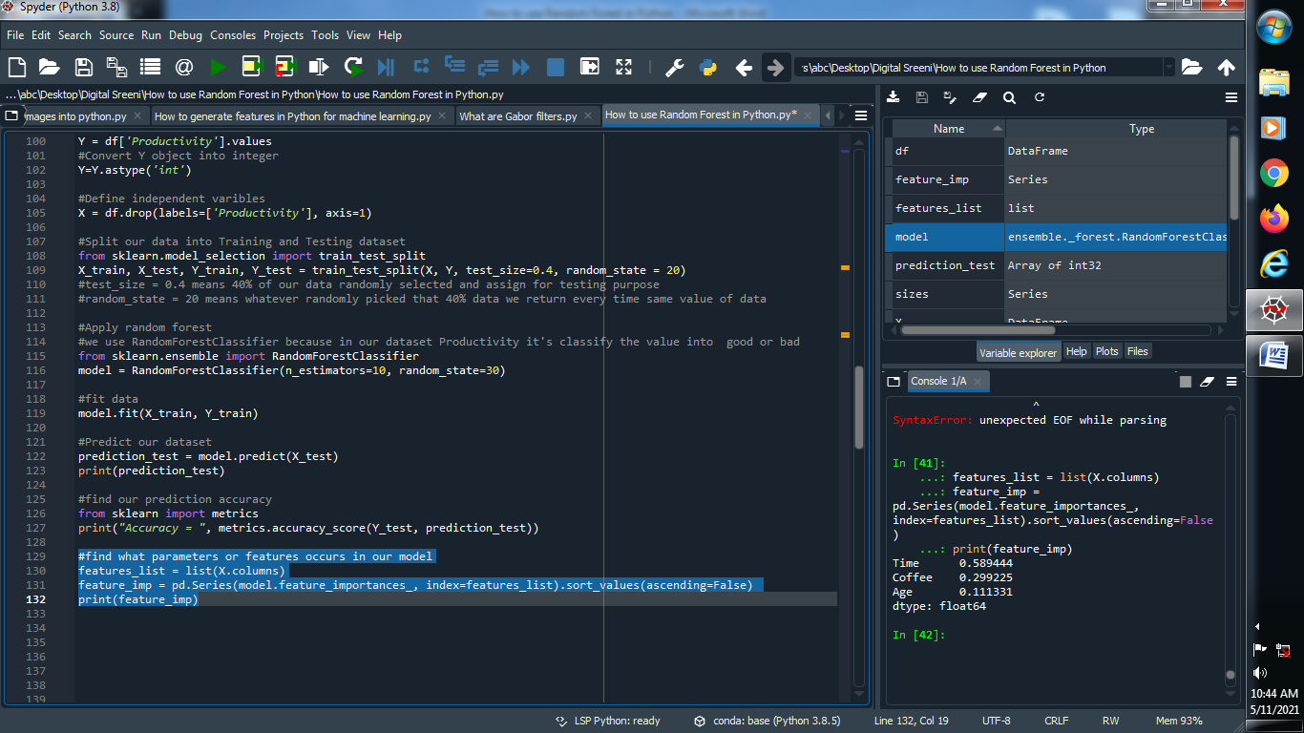

**Output :**

